**Author Portfolio Website**

I created the Home, Books, About Me, and Contact Me pages inside the en folder in AEM.

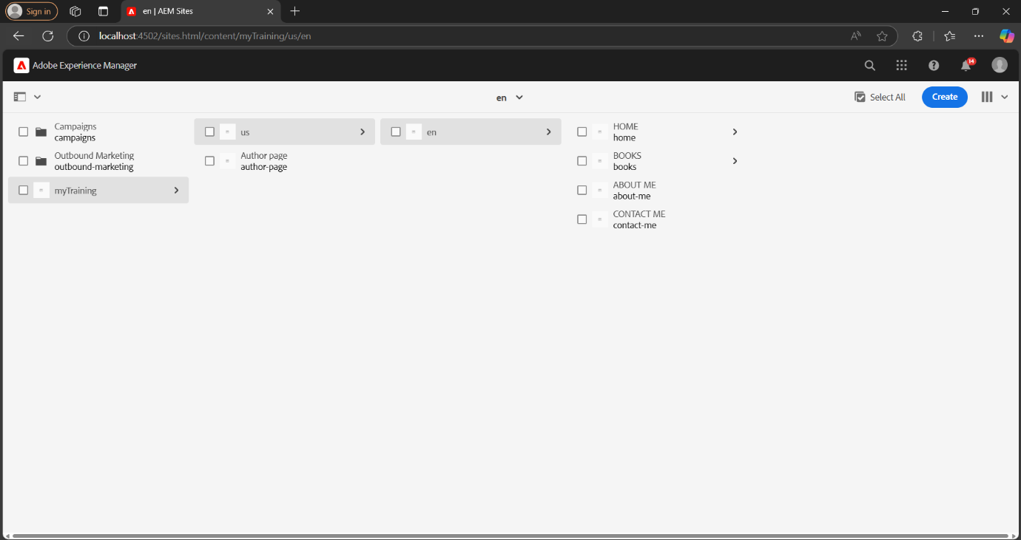

Inside the Home page, I created Award Pages to showcase the author's achievements using the teaser component.

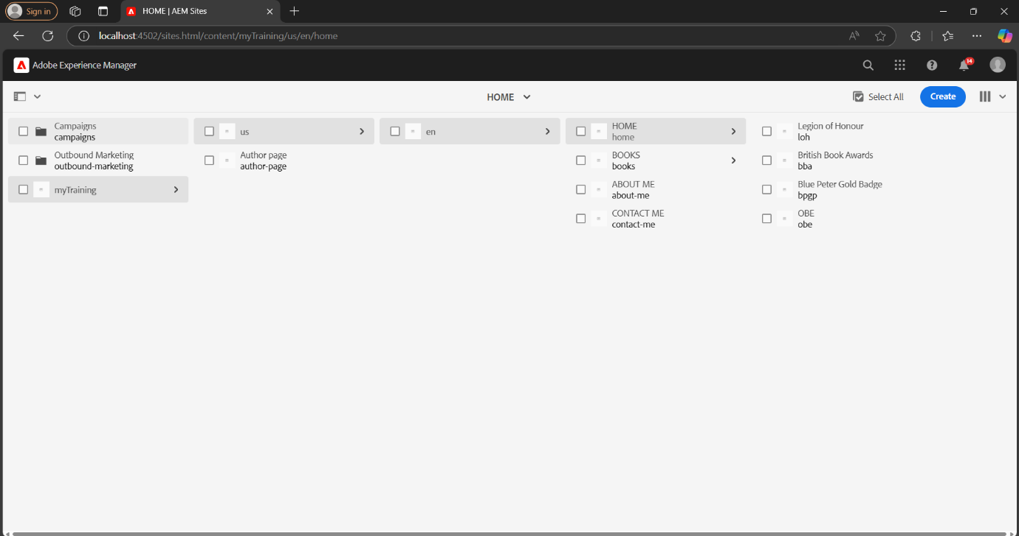

Inside the Books page, I created Three book pages: Harry Potter and the Goblet of Fire, Harry Potter and the Order of the Phoenix and The Ickabog.

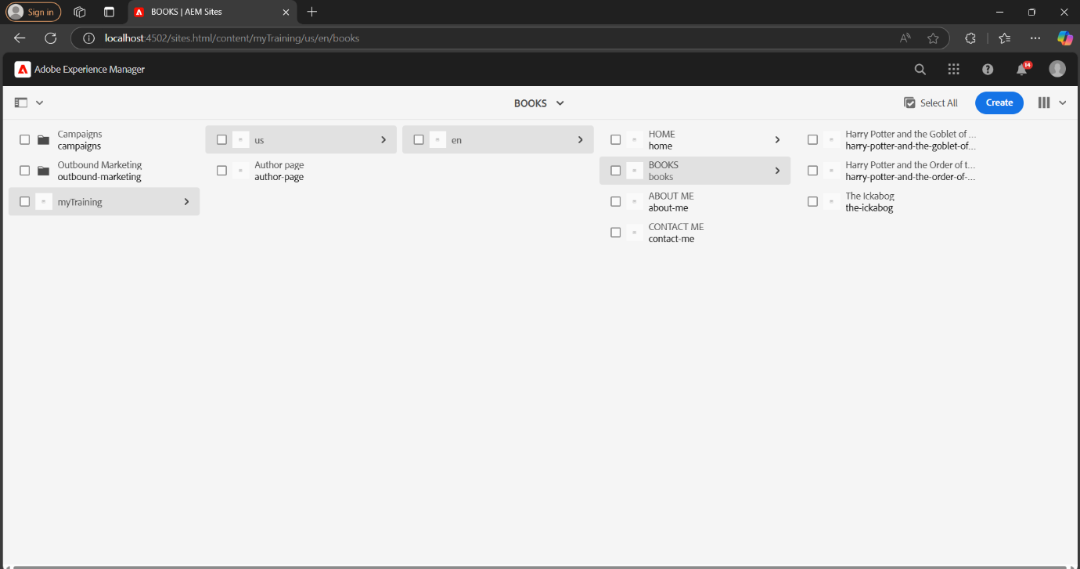

**1.HOME PAGE**

The **Home Page** of the Author Portfolio Website highlights the achievements of the author. A teaser component showcases an **award ceremony**, featuring an **image and title**. Visitors can click the **Call-to-Action (CTA)** to read the full details on a dedicated award page.

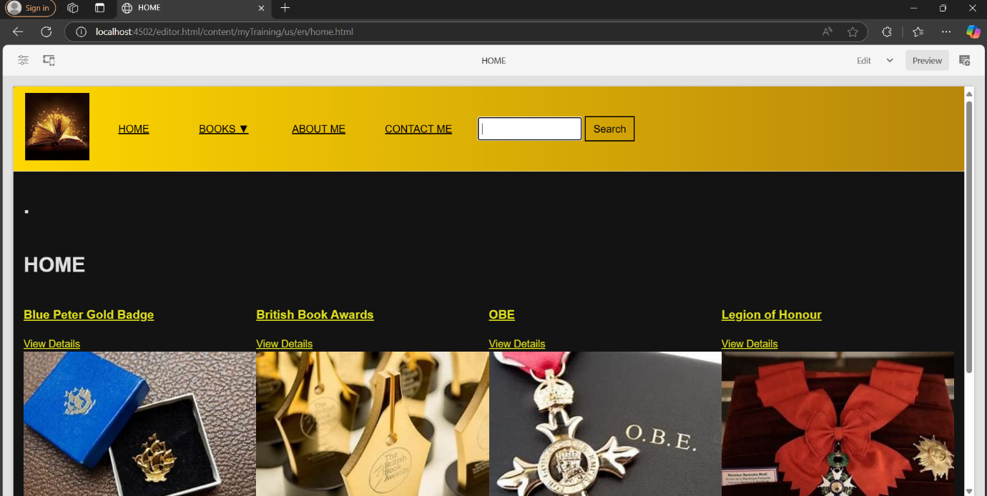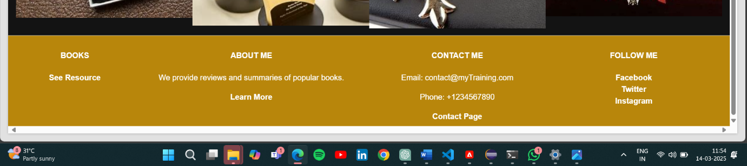

The **dropdown menu** in the **Home Page header** provides easy navigation to different book pages. Under the **"Books"** tab, users can hover to reveal a list of books.Each book name is a clickable link that directs users to its dedicated page. This feature ensures a smooth and organized browsing experience for visitors.

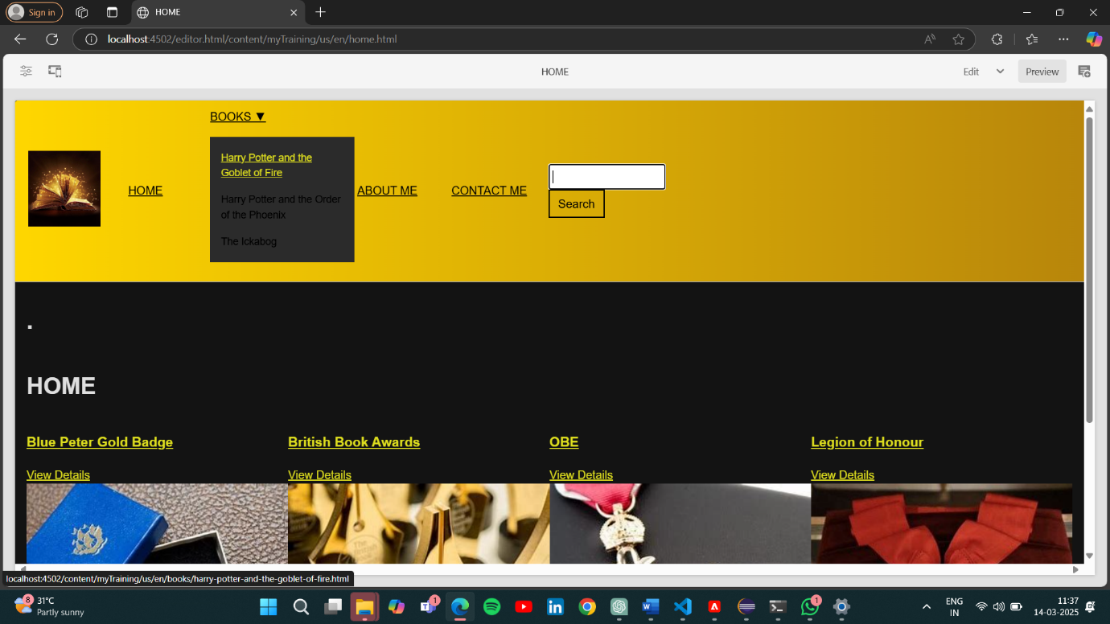

Each Book in the dropdown of Books includes text, image, and title components to provide engaging content. The layout ensures a visually appealing and informative experience for visitors.

**1.Harry Potter and the Order of the Phoenix**

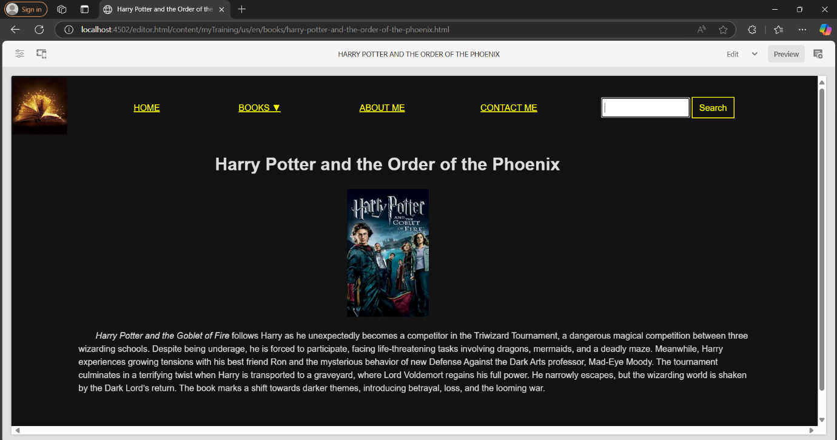

**2.The Ickabog**

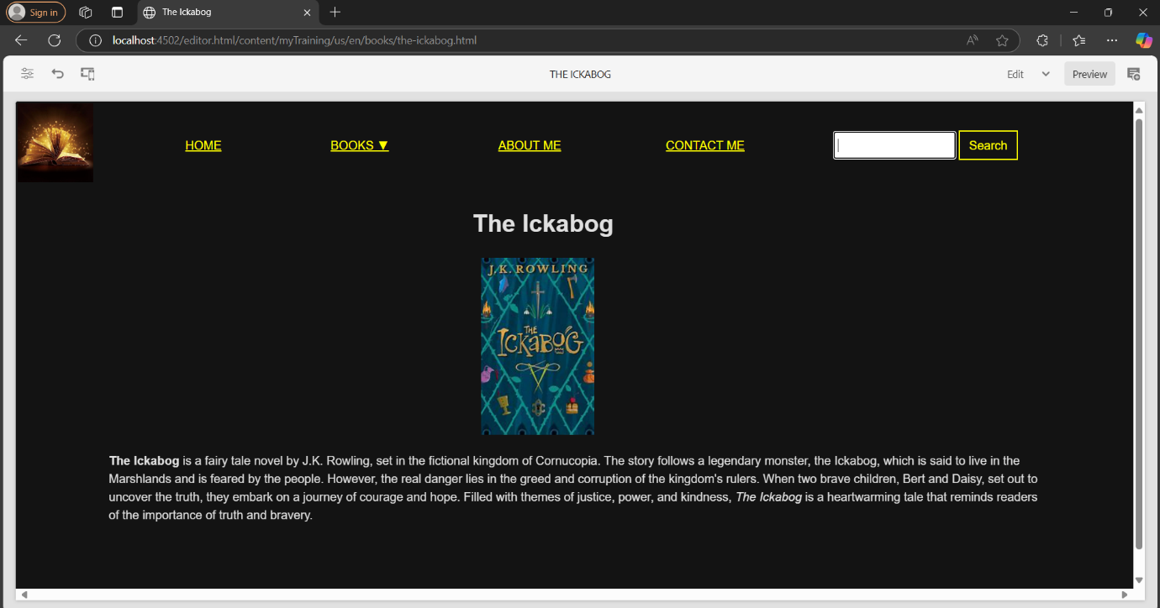

**3.Harry Potter and the Goblet of Fire**

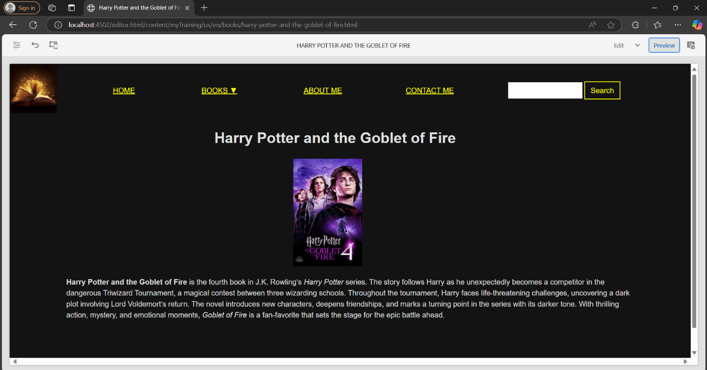

The award pages includes **text, image, and title components** to provide engaging content. The layout ensures a visually appealing and informative experience for visitors.

1. **Blue Peter Gold Badge**

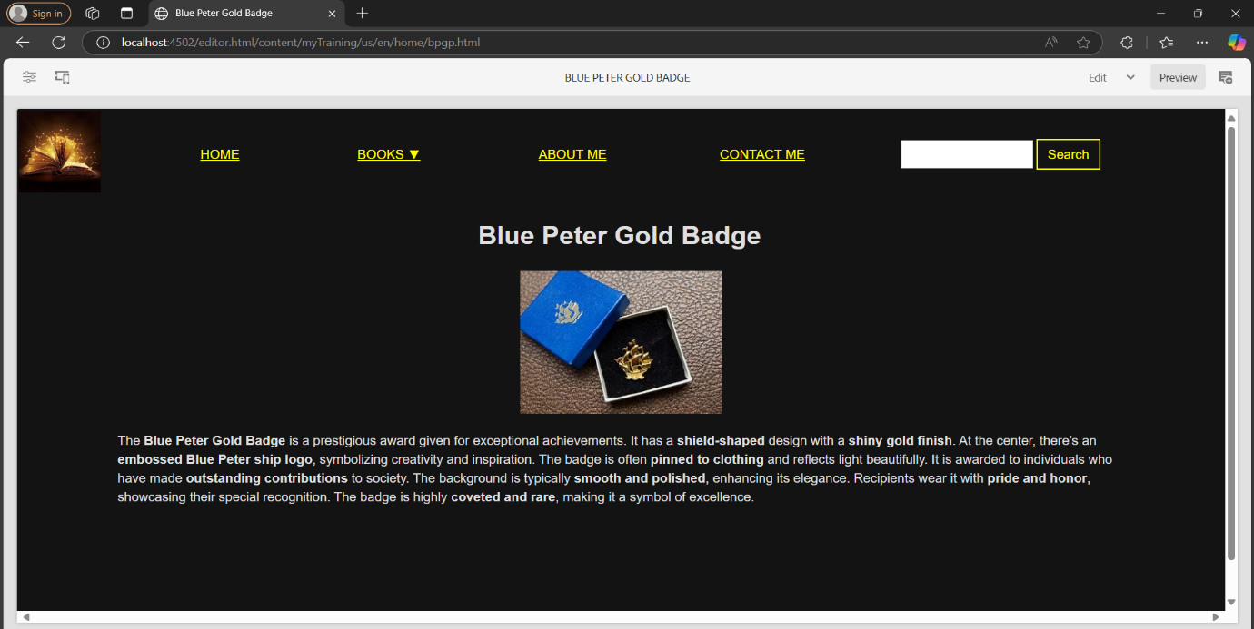

**2.  British Book Awards**

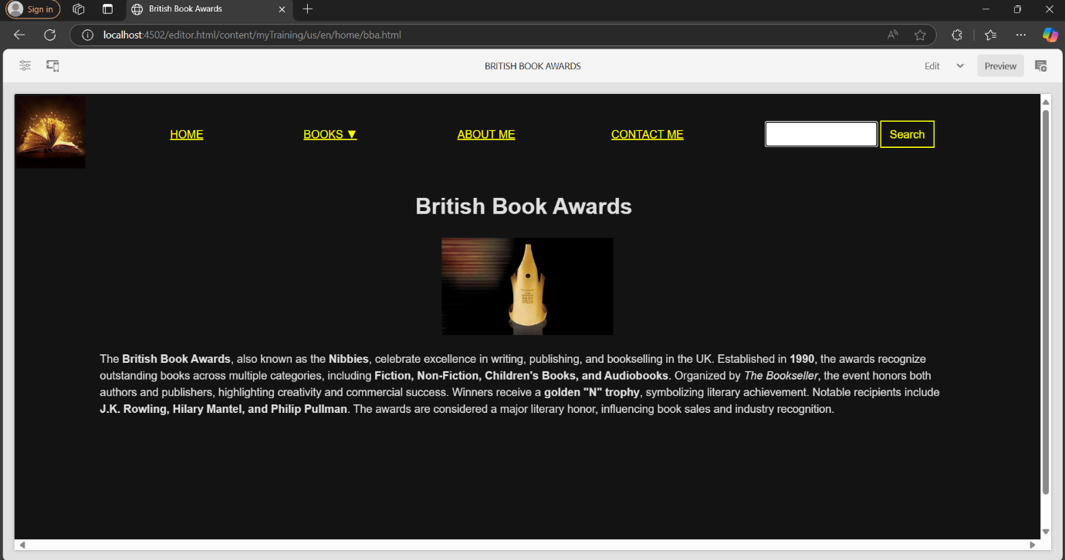

**3. officer of the order of the british empire**

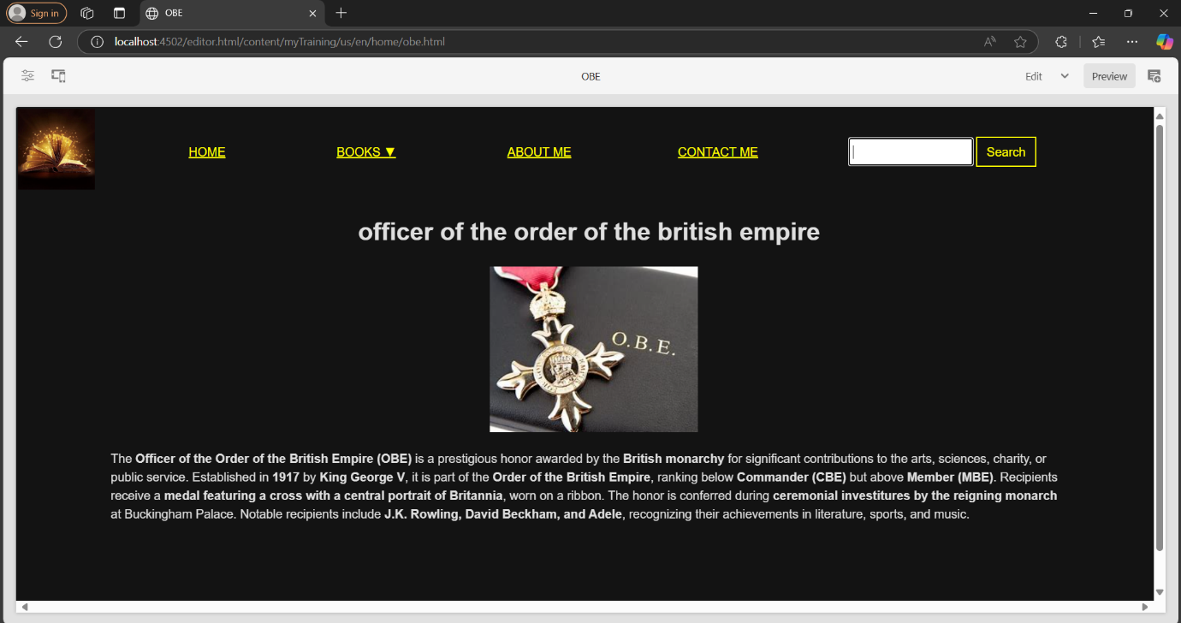

**4. Legion of Honour**

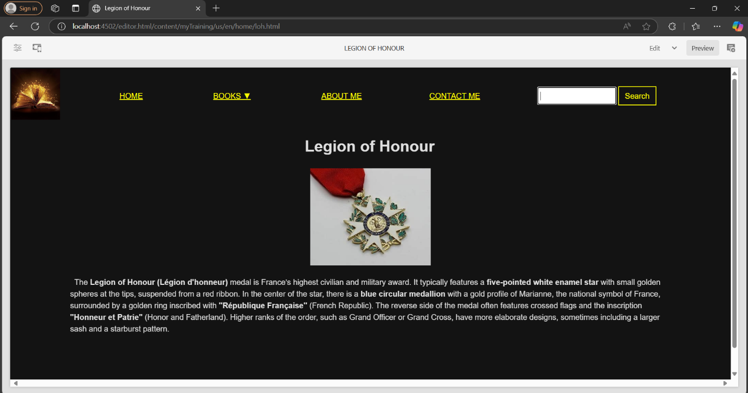

**2.BOOKS PAGE**

The Books Page showcases a collection of books written by the author. A custom Book Component dynamically fetches and displays book details from the /content/books folder. Each book is presented as a card featuring a title, description, and image.

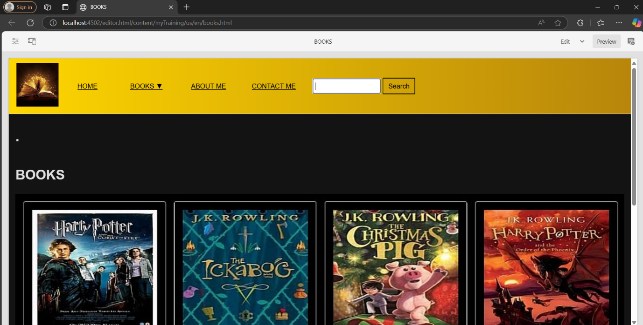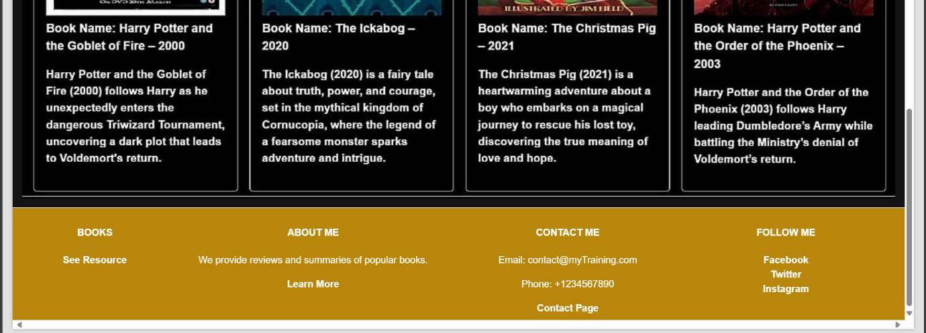

**3.ABOUT ME PAGE**

The About Me page features the Author Component, providing a detailed biography of the author. It includes the author's name, image, and a brief description of their journey, achievements, and notable works. This page offers visitors an insight into the author's background and literary contributions in a well-structured and visually appealing format.

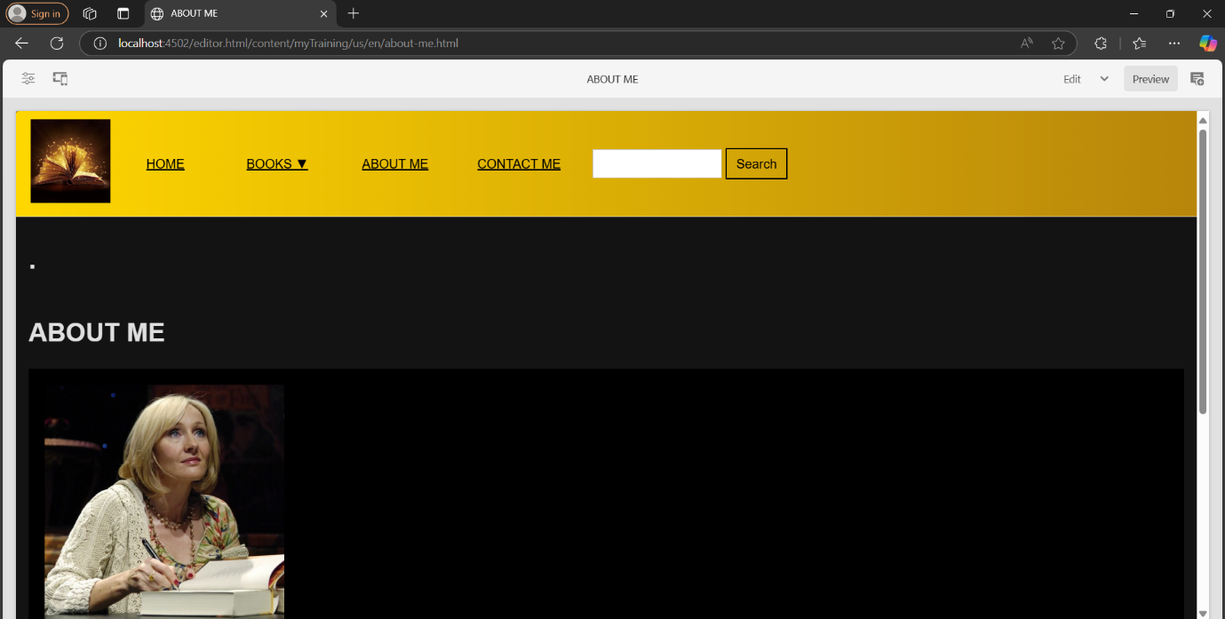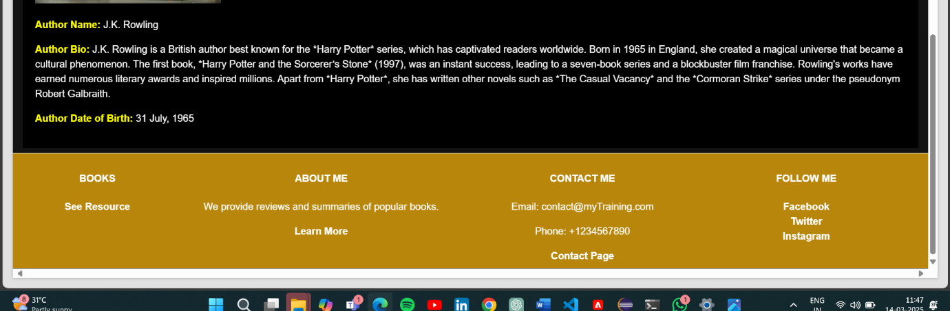

**4.CONTACT ME PAGE**

The **Contact Me** page includes **text and teaser components** to provide essential contact details. It features the author's **email, phone number, and social media links**, allowing visitors to connect easily. The page is designed for accessibility, ensuring a user-friendly experience for those looking to reach out or follow the author on various platforms.

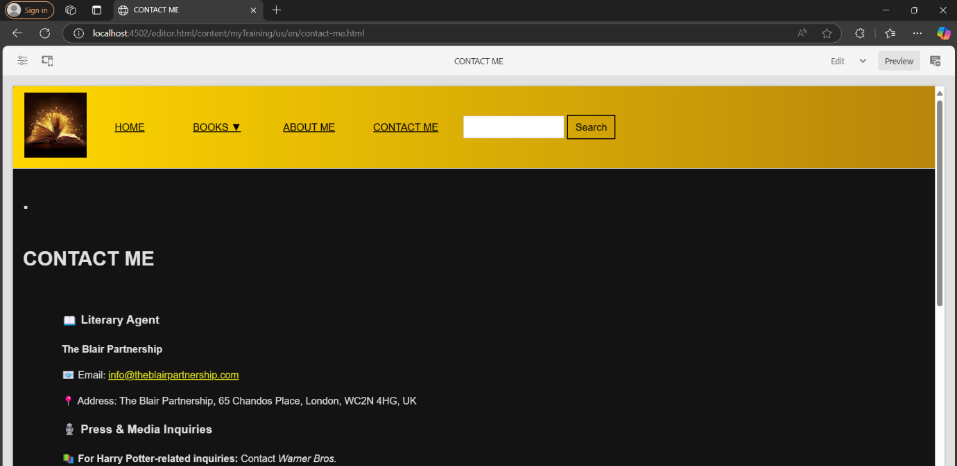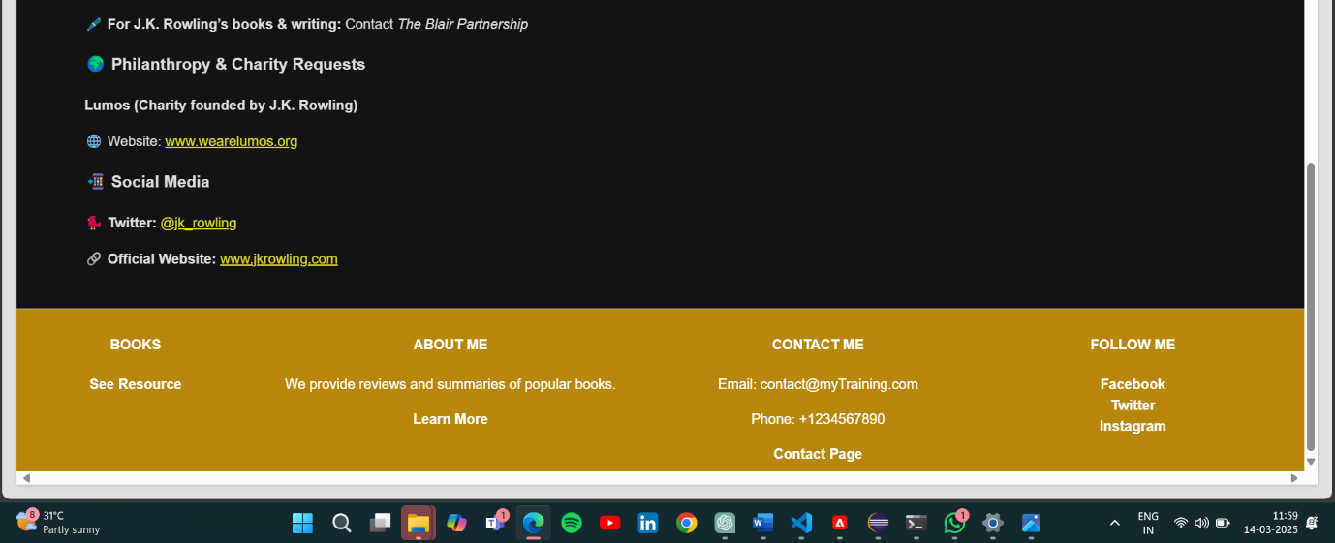

The **site.js** script is used to dynamically fetch and display book cards on the **Books** page. It retrieves book data from the authored content under the /content/books hierarchy and generates cards with the **title, description, and image** for each book.

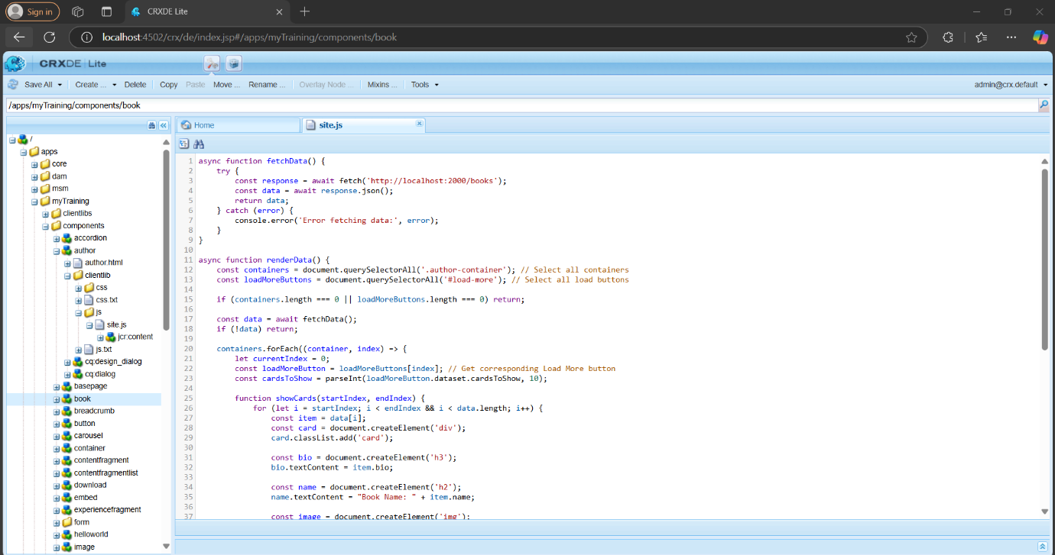

The **author.html** file is used to render the **Author Component** on the **About Me** page in AEM. It fetches and displays details like the author's **name, biography, date of birth, and profile image**

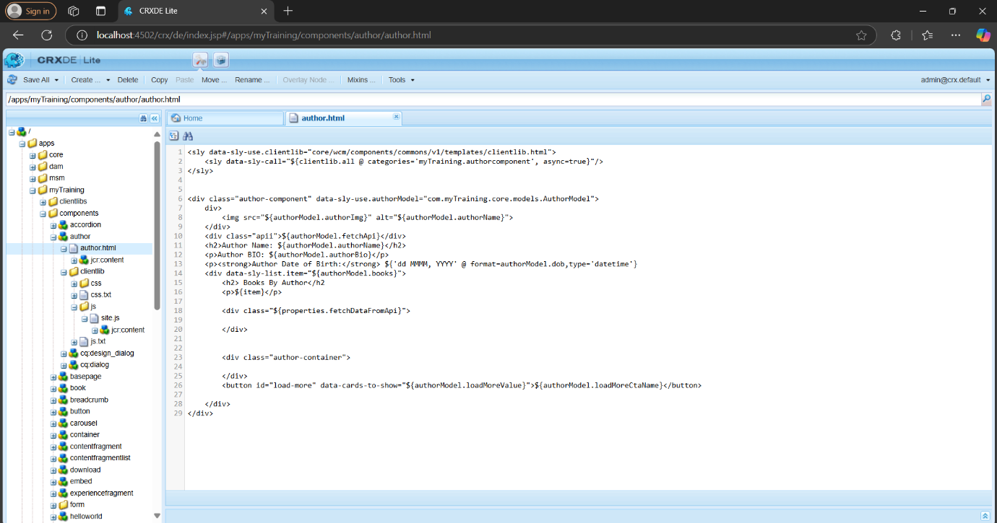

In **Eclipse**, the **header.scss** and **footer.scss** files are used to style the **header** and **footer** sections of the website.

1.header.scss

/ui.frontend/src/main/webpack/site/styles/header.scss

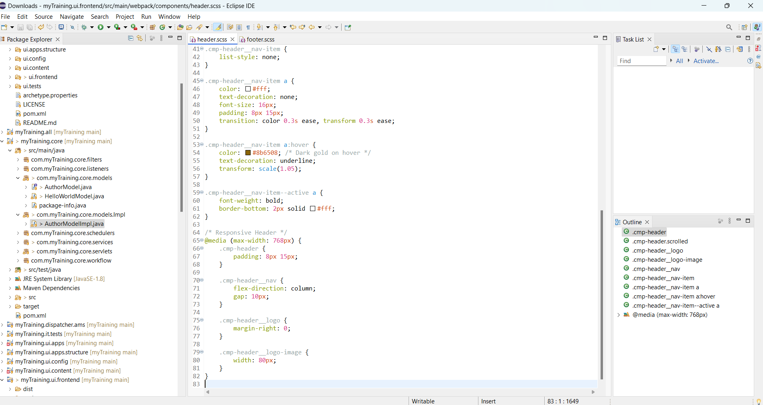

2.footer.scss

/ui.frontend/src/main/webpack/site/styles/footer.scss

